Preliminary Plan for Final Course Project
Project Overview
For my final course project, I plan to develop a Python based structural analysis program using the direct stiffness method for mixed 3D truss and 3D frame systems. The program will be able to analyze structures containing both element types within the same codebase, with the user specifying the type of each member in the structural model. The main goal of the project is to build a general Python program capable of handling both 3D truss and 3D frame elements in a single implementation. My overall goal is to create a program that is organized, reusable, and practical for structural modeling. The user will define the structure through an input file rather than editing the source code directly. The program will then preprocess the model data, assemble the global system, solve for the unknown displacements, and report the important response quantities in a clear and organized way. The final implementation will first be tested on validation problems with known solutions and then applied to a more complex bridge structure containing both truss and frame members. At this stage, I already have an initial repository structure and an existing code base from earlier course assignments. My plan is not to start over completely, but to build from my current progress and extend it into a more general and better organized final project. The main additions will be the 3D element routines, mixed element handling, improved input organization, and a clearer output structure.
Planned Repository and Code Organization
The project requires a GitHub repository that is organized, clear, and easy for another user to run. My repository has already been created and includes the main notebook, helper functions, example files from earlier assignments, folders for validation and final bridge inputs, output folders, and a bridge reference folder for source material. Although the structure will continue to be refined, it already shows the main project components in a logical way.
My code organization will follow three main parts. The first part is user input and preprocessing, where the program will read a structured input file, likely in JSON format, containing nodes, elements, element types, material and section properties, supports, loads, prescribed displacements, and other required data. The second part is the DSM analysis loop, where the code will assemble and solve the structural system and will be extended to handle both 3D truss and 3D frame elements, along with features such as releases, temperature loading, fabrication error, and support displacements. The third part is output and results presentation, where the program will save results such as nodal displacements, reactions, and member forces in organized folders and generate useful summaries, tables, and figures for each analysis case.
Project Components and Implementation Plan
The final project consists of three main deliverable components in the repository. These are the Python code, the report, and the final presentation. My implementation plan for the code is as follows.
First, I will reorganize and clean up my current notebooks and helper functions so that the repository is easier to follow. Some of my current work is based on earlier assignments and intermediate code versions, so one of the first steps is to convert that progress into a cleaner final structure. Second, I will extend the existing implementation to support the required 3D element capabilities. This includes incorporating a 3D truss formulation and a 3D frame formulation within the same overall framework, using the simplifying assumptions allowed by the project statement for the frame element. Third, I will use previously solved examples from the course as validation cases. These examples are especially valuable because their correct solutions are already known, making them appropriate for checking whether the code is behaving correctly. Fourth, after the validation stage, I will build the final complex structure model for the selected bridge. This part will require assembling geometry, selecting member idealizations, defining supports and loads, and interpreting the results critically rather than only producing numerical output.
Validation Plan
My validation strategy will be based on examples that we have already solved in previous assignments. The reason behind choosing it is the fact that these are not unknown test cases. They are problems whose behavior and solutions are already known/ calculated, which makes them appropriate benchmarks for the new implementation.
The validation cases I plan to use include previously solved examples involving support settlement, fabrication error, and temperature effect, along with a previously solved 3D truss example from earlier in the course. The examples include 3D truss behavior, which makes it especially useful for verifying that the 3D code is functioning correctly. In the final report, I plan to present each validation study with the structure description, the input data, the known/ hand solved solution, the computer model input, the code results, and a comparison between expected and computed behavior.
Preliminary Description of the Final Structure
For the final modeling study, I plan to use the historic Fort Griffin Iron Truss Bridge described in the report Evaluation and Rehabilitation of Historic Metal Truss Bridges: A Case Study of an Off-System Historic Metal Truss Bridge in Shackelford County, Texas. The bridge is located on County Road 188 near Fort Griffin in Shackelford County, Texas, and was originally constructed in 1885 by the King Iron and Bridge Manufacturing Company of Cleveland, Ohio. It is historically important because it is one of the oldest surviving truss bridges in Texas and the last remaining pin connected Pratt through truss in Shackelford County. (Maniar et al., 2003)
The bridge is a wrought iron pin connected Pratt through truss. The main span is about 109 to 110 ft long, with an overall width of about 20 ft, a clear roadway width of about 13 ft 6 in, and a truss height of about 18 ft. Figures 1 through 3 illustrate the main visual and structural features of the Fort Griffin Iron Truss Bridge, including the interior truss and deck arrangement, the overall side elevation of the bridge, and the underside floor system supported by the pier (Historic American Engineering Record [HAER], 1996)The main span floor system consists of timber deck planks supported by longitudinal timber stringers and transverse metal floor beams, while the main span itself is supported on masonry or limestone piers. For the analytical model, the bridge will be considered under dead load together with a simplified vehicle load case so that the structure can be studied under a more realistic service type loading condition.
In this project, I will model only the main span rather than the entire bridge. This is a deliberate scope decision because the main span already captures the most important mixed behavior needed for the final project, combining axial dominant truss members with bending members in the floor system. The main truss members will be modeled primarily as 3D truss elements, while the transverse floor beams and longitudinal timber stringers will be modeled as 3D frame elements. The timber deck planks will not be modeled explicitly, and their effect will instead be represented through simplified loads applied to the stringers and floor beams. The approach spans will not be included because modeling them would require additional assumptions about the metal bents, bracing, connection behavior, and support idealization, and the report itself places greater emphasis on the truss span than on the approach spans.
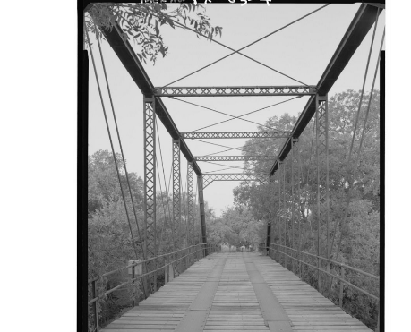
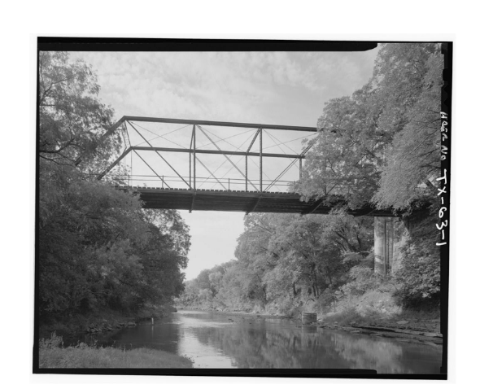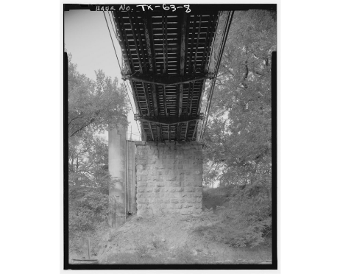
Figure3: Underside view of the main span
Figure.2: Interior roadway view of the main truss span
Figure.1: Interior roadway view of the main truss span

Feasibility of the Chosen Bridge
The Fort Griffin bridge is a chosen because the case study report contains substantial technical information. According to the report, the study of the Shackelford County bridge included data collection, material evaluation, structural analysis and load rating, field load testing, and development of rehabilitation options. The table of contents and summary show that the document includes bridge history, bridge description, floor system details, truss geometry, support information, material properties, analysis models, load ratings, field testing, and rehabilitation discussion. It also includes photographs in Appendix A and drawings in Appendix B.

References
Maniar, D. R., Engelhardt, M. D., & Leary, D. E. (2003, March 1). Evaluation and rehabilitation of historic metal truss bridges: A case study of an off-system historic metal truss bridge in Shackelford County, Texas (FHWA/TX-03/1741-3). Center for Transportation Research, The University of Texas at Austin. https://rosap.ntl.bts.gov/view/dot/86168
Historic American Engineering Record, (HAER). 1996. “Fort Griffin Iron Truss Bridge”, HAER No. TX-63, the report prepared as a part of the Texas Historic Bridge Recording Project sponsored by the Texas Department of Transportation.

